Lesson 13: Angles, Arc Length & Angular Speed
Math 2412 Precalculus · Unit 3: Trigonometric Functions & Triangles · Student Guided Notes
Name: ______________________________ Date: ______________

Lesson objective
Students will draw angles in standard position, convert between degrees and radians, find coterminal and reference angles, and use radian measure to find arc length, sector area, and linear and angular speed.

Before class
Complete these short tasks before the lesson. They review skills this lesson builds on.
- Find the circumference of a circle with radius 5 inches. Leave your answer in terms of π.
- Simplify $150·π/180$ and $(7π/6)·(180/π)$.
- A wheel with radius 2 feet turns 3 full times. How far does a point on its rim travel?

Skill 13.1: Angles & Radian Measure

Key ideas
- An angle is formed by rotating a ______________ (1) about its endpoint, called the ______________ (2). The ray starts on the initial side and stops on the ______________ (3).
- An angle is in standard position when its vertex is at the origin and its initial side lies along the ______________ (4).
- A counterclockwise rotation gives a ______________ (5) angle; a clockwise rotation gives a ______________ (6) angle.
- One degree is ______________ (7) of a full rotation. An angle whose terminal side lies on an axis (0°, 90°, 180°, 270°, 360°) is a ______________ (8) angle.
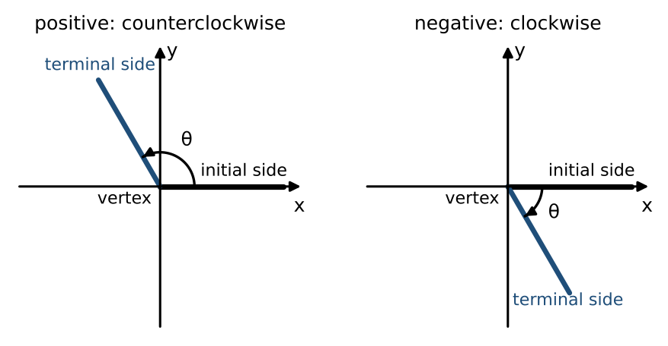

Example 1: sketch 30° and −135° in standard position
Divide by 360° to find the fraction of a turn. 30° is $\frac{30}{360}=\frac{1}{12}$ of a turn counterclockwise, in quadrant I. −135° is $\frac{135}{360}=\frac{3}{8}$ of a turn clockwise, ending in quadrant III.
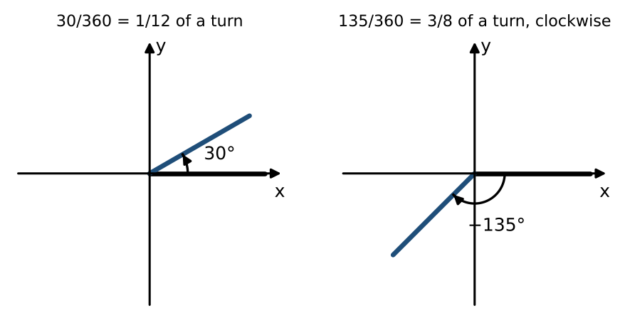

Radian measure
One radian is the central angle whose arc is as long as the radius. In general, $θ=\frac{s}{r}$ radians. A full turn is ______________ (9) radians, so $360°=2π$ and $180°=π$.
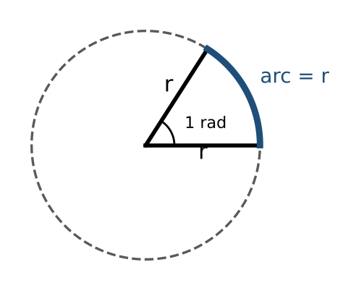
- A radian is a ratio of two lengths, so it has no units. An angle with no degree symbol is in ______________ (10).
- Degrees to radians: multiply by ______________ (11). Radians to degrees: multiply by ______________ (12).
Degrees | 30° | 45° | 60° | 90° | 120° | 135° | 150° | 180°
Radians | ________ (13) | ________ (14) | ________ (15) | $π/2$ | ________ (16) | ________ (17) | ________ (18) | $π$

Example 2: convert
- Radians to degrees: $π/6·180/π=30°$; $3·180/π≈171.89°$; $5π/4·180/π=225°$.
- Degrees to radians: $120·π/180=2π/3$; $300·π/180=5π/3$; $127·π/180=127π/180≈2.217$.

Practice
a. Convert 210° and −45° to radians. | b. Convert $11π/6$ and 2.5 radians to degrees.
c. Sketch $5π/3$ in standard position. Which quadrant is it in?  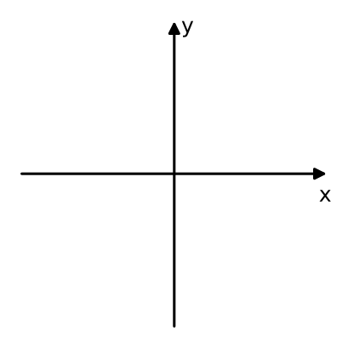 | d. Is 4 radians more or less than 180°? Which quadrant is it in?

Skill 13.2: Coterminal & Reference Angles

Key ideas
- Coterminal angles share the same ______________ (19). Find them by adding or subtracting full turns: $θ±360°k$, or $θ±2πk$ in radians.
- Example: 140° and −220° are coterminal because $140°−360°=−220°$.
- The reference angle is the ______________ (20) angle between the terminal side and the ______________ (21). It is always positive.
Quadrant I | Quadrant II | Quadrant III | Quadrant IV
$θ$ | ________ (22) or $π−θ$ | ________ (23) or $θ−π$ | ________ (24) or $2π−θ$

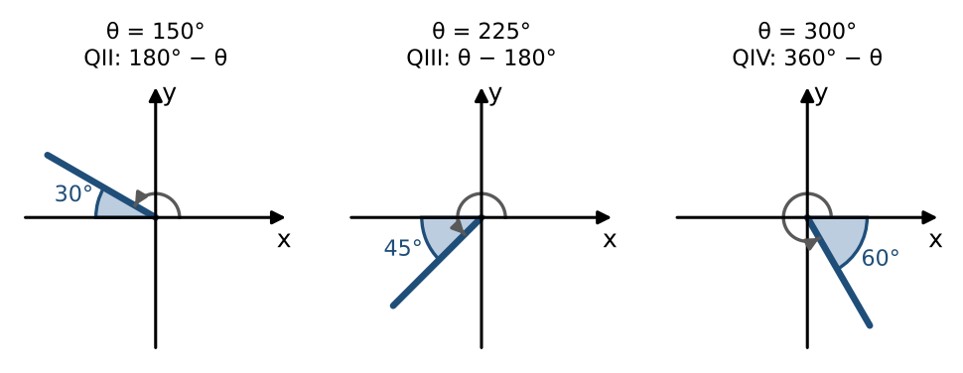

Example: least positive coterminal angle, then the reference angle
- 800°: subtract 360° twice: $800°−720°=80°$. Quadrant I, so the reference angle is 80°.
- $19π/4$: subtract $2π=8π/4$ twice: $19π/4−16π/4=3π/4$. Quadrant II, so the reference angle is $π−3π/4=π/4$.
- −220°: add 360°: $−220°+360°=140°$. Quadrant II, so the reference angle is $180°−140°=40°$.

Practice
a. Find the least positive angle coterminal with −500°. | b. Find the least positive angle coterminal with $31π/6$.
c. Find the reference angle of 300° and of $11π/6$. | d. Find the reference angle of $−2π/3$.

Skill 13.3: Arc Length & Sector Area

Key ideas
Arc length: $s=rθ$. Sector area: $A=(\frac{1}{2})r^{2}θ$. In both formulas θ must be in ______________ (25).
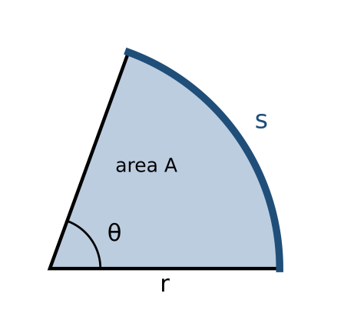

Example 1: arc length
Find the arc length on a circle of radius 10 units subtended by an angle of 215°. Convert first: $215·π/180=43π/36$. Then $s=10·43π/36=215π/18≈37.52$ units.

Example 2: sector area
A lawn sprinkler sprays 20 feet while rotating 30°. What area does it water? $30°=π/6$, so $A=(\frac{1}{2}){(20)}^{2}(π/6)=100π/3≈104.72$ square feet.

Practice
a. Find the arc length on a circle of radius 8 cm for $θ=3π/4$. | b. An arc of length 12 inches lies on a circle of radius 5 inches. Find the angle in radians and degrees. | c. Find the area of a sector with radius 6 m and angle 120°.

Skill 13.4: Linear & Angular Speed

Key ideas
- Angular speed is the rotation per unit time: $ω=θ/t$, in radians per unit time.
- Linear speed is the distance along the circle per unit time: $v=\frac{s}{t}$.
- Because $s=rθ$, the two are related by ______________ (26) (ω in radians per unit time).
- One revolution is ______________ (27) radians, so revolutions per minute (rpm) times 2π gives radians per minute.

Example 1: a record turntable
A record turns at 45 revolutions per minute. Find its angular speed in radians per second. $ω=45·2π/60=3π/2≈4.71$ radians per second.

Example 2: a bicycle
Bicycle wheels are 28 inches in diameter and turn at 180 rpm. How fast is the bicycle moving?
- $r=14$ inches; $ω=180·2π=360π$ radians per minute.
- $v=rω=14·360π=5040π≈15,834$ inches per minute.
- In miles per hour: $5040π·60≈950,000$ inches per hour, and a mile is 63,360 inches, so about 15.0 mph.

Practice
a. A wheel of radius 30 cm turns 4 revolutions per second. Find its angular speed and the linear speed of a point on the rim. | b. A Ferris wheel of radius 50 feet makes one revolution every 2 minutes. How fast does a rider move?

Exit check
1. Convert 240° to radians.

2. Find the arc length on a circle of radius 9 for $θ=2π/3$.

3. A disk turns at 300 rpm. Find its angular speed in radians per second.

